This document is merely to point out the differences in confessional count numbers between my findings and the official numbers posted on Survivor Sucks. The guidelines I use can be found [here](https://docs.google.com/document/d/18ofsPiVWxSejzSjEGlU8KEx4Og2ddEJScCV23RsCPIA/edit?usp=sharing).

**Survivor Sucks Season 12 Counts** ([link](https://goo.gl/photos/rtjKmiAJ92ckKJg36))

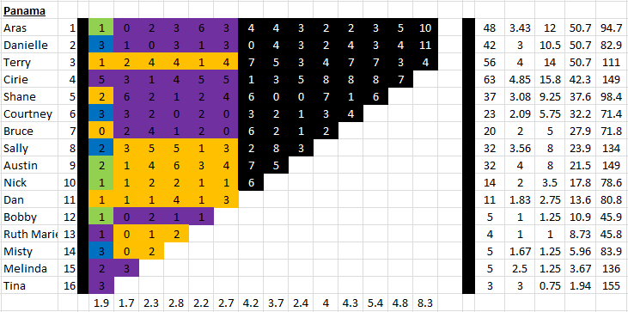

**My Season 12 Counts** ([link](https://photos.app.goo.gl/TO41dd2uWalOwd3H2))

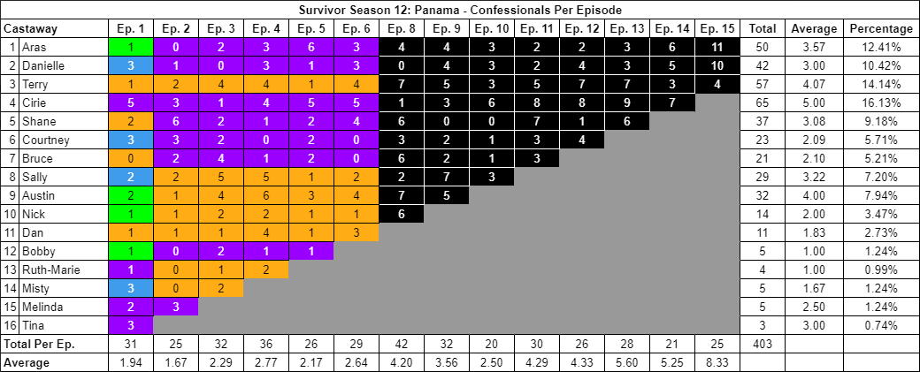

[Survivor Sucks Season 12 thread](http://survivorsucks.com/topic/2625).

**Differences**

[Episode 02](https://docs.google.com/document/d/1rl5S16zG9fU8QhvpEee0cfJD94BuO589VUj8fgHNKsQ/edit?usp=sharing)

* **Sally 2 (-1)** Confessional #15 has a 9s gap.
  + **Notes:**
    - Confessional #1 is an on-the-fly Shane confessional has he talks next to the shelter as it rains. Chyron present.
    - Confessional #2 is an on-the-fly Shane confessional as he walks along the beach and the camera follows. Chyron present.
    - Confessional #9 is an on-the-fly Dan confessional as he talks next to the shelter. Chyron present.
    - Confessional #13 is a Bruce voice over.

[Episode 06](https://docs.google.com/document/d/11D9eHgg6_DAoBKCKGhoIe7xddNldJdojvYFvvZEkRM8/edit?usp=sharing)

* **Sally 2 (-1)** Confessional #13 has a 9s gap.

[Episode 09](https://docs.google.com/document/d/1c6FMQqGiz78XnVneYJp4vSHprLW57E_0GK7nLMPvAmo/edit?usp=sharing)

* **Sally 7 (-1)** Confessional #7 has a 9s gap, which is followed by a 10s gap.
* **Note:** The last part of confessional #14 has an on-the-fly segment as Cirie talks from the shelter and there’s someone sleeping next to her.

[Episode 10](https://docs.google.com/document/d/1qDVn0RB4vZigwhvm7jpRFzpoxv3fXq3TPZLQ4ypkMS0/edit?usp=sharing)

* **Cirie 6 (+1)** Confessional #12 has an 11s gap.
* **Notes:**
  + Second half of confessional #11 is on-the-fly as Terry stands next to the shelter and addresses the camera.
  + Confessional #17 is an on-the-fly Bruce confessional as he gives it inside the shelter. Chyron present.

[Episode 11](https://docs.google.com/document/d/1P8l1uJjiqjJO5F5ejH6EFfcOu9Q1l1Zn3we8_Z1-tiU/edit?usp=sharing)

* **Terry 5 (+1)** Confessional #1 has an 11s gap, and confessional #30 is a voice over.
* **Bruce 3 (+1)** Confessional #11 is an on-the-fly Bruce confessional in which he stands next to a tree and narrates about his injuries. No chyron.
* **Notes:**
  + Confessionals #10 & #12 are on-the-fly Shane confessionals in the same setting, in which Shane sits next to the fire and narrates.
  + Confessional #13 is an on-the-fly Bruce confessional that he gives inside the shelter. Chyron present.
  + Confessional #28 is an on-the-fly Courtney confessional that she gives as she cleans Bruce’s rock garden. Chyron present.
  + As Bruce is going to be medevaced, Shane looks directly to the camera and says briefly why he is naked. This could be considered an on-the-fly confessional.

[Episode 13](https://docs.google.com/document/d/1ubKB9OzfYOGvbONW7gW3Sg2xn-F7BqZ_2DdxvSn-EoY/edit?usp=sharing)

* **Cirie 9 (+1)** Confessional #15 is an on-the-fly confessional in which she looks directly at the camera and narrates. No chyron present.

[Episode 14](https://docs.google.com/document/d/15dkivU_Bq55PGMD37WCbngsBWI9OhtWgQ1qzkRjpxx4/edit?usp=sharing)

* **Aras 6 (+1)** Confessional #14 is an on-the-fly Aras confessional in which he is inside the shelter resting on his side and talking directly to the camera. Chyron present.
* **Danielle 5 (+1)** Confessional #17 has an 11 second gap.
* **Notes:**
  + Confessionals #1 & #11 are Cirie voice overs.
  + Confessional #13 is a Cirie confessional that has a voice over sandwiched in between on-the-fly elements as she narrates making the fire. No chyron.

[Episode 15](https://docs.google.com/document/d/1e6i2vOVCgU6H6pFjG4TmxkCjTtkyeqaNa__tA_MGE4Q/edit?usp=sharing)

* **Aras 11 (+1)**
  + Confessional #6 is an on-the-fly confessional with chyron present.
  + Confessional #14 has an 11s gap.
  + Confessional #18 is an on-the-fly confessional without a chyron.
* **Danielle 10 (-1)** Confessional #10 has a 9s gap.
* **Notes:**
  + Confessional #3 is a Terry on-the-fly confessional with chyron present.
  + Confessional #9 is a Terry voice over.

**No Change**

* [Episode 01](https://docs.google.com/document/d/1a8T_xL2KZayPnxETlA9I3tbDU3GjULGZjFqKmItpREs/edit?usp=sharing)
* [Episode 03](https://docs.google.com/document/d/1UfIVDFzEsiwB5NKeFyHlWkxpMOI6Gn1iv1YSI7TL-uI/edit?usp=sharing)
  + **Notes:** Confessionals #18 & #19 are voice overs.
* [Episode 04](https://docs.google.com/document/d/1DsdsdTuHqnlxY4yUWucEhvccYVIv55rJbh-dmY2gt7Y/edit?usp=sharing)
  + **Notes:**
    - Confessional #1 is an on-the-fly Sally confessional in which she talks with the shelter and visible tribemates behind her. Chyron present.
    - Confessional #2 is a Dan voice over.
    - Confessional #23 is an on-the-fly Nick confessional in which he talks to the camera as he paddles the raft. Chyron present.
* [Episode 05](https://docs.google.com/document/d/1H4iq-cj7CQKRo-5tonUpWZRlszd4DVlyXYHpW4zgol4/edit?usp=sharing)
  + **Notes:**
    - Confessionals #9 & # 11 have the same on-the-fly confessional setting in which the whole tribe is behind Aras as he talks to the camera. Confessional #9 has the chyron, while #11 doesn’t.
    - Confessional #13 is a debatable confessional in terms of the content, because it either ends right before Austin is seen talking inside the shelter with Nick next to him, which would make it a voice over, or it includes this segment and it becomes an on-the-fly confessional. The transition is very seamless so I lean towards the latter.
    - Confessional #14 is an on-the-fly Nick confessional in which he sits in the shelter. Chyron present.
* [Episode 08](https://docs.google.com/document/d/1Dk3LhudJd2RsdmM7D_gyYj6Ohd-6ZOOTYeiXwR-wUe4/edit?usp=sharing)
* [Episode 12](https://docs.google.com/document/d/1pVx3FQtiaIX6atfLmDCF3BrGMK7-z3Ll8JoMaKJSptY/edit?usp=sharing)
  + **Notes:**
    - Confessionals #2 & #3 are part of a dual confessional between Shane and Danielle, that takes place in different settings. Shane starts with a confessional (#2), which has a chyron present. Once he finishes, there is a 7s gap and Danielle starts a confessional (#3) with chyron present. As she does so, there are various instant cuts back to the previous setting where Shane was giving his initial confessional and returning to Danielle. This happens a couple of times. Because of the 7s gap, I counted this as a dual confessional, with no change on Shane’s final count.
    - Confessional #10 is an on-the-fly Cirie confessional in which she talks in front of the camp fire. No chyron present.

|  |  |  |
| --- | --- | --- |
| **Castaway** | **Count** | **Change** |
| Aras | 50 | +2 |
| Danielle | 42 | - |
| Terry | 57 | +1 |
| Cirie | 65 | +2 |
| Bruce | 21 | +1 |
| Sally | 29 | -3 |
| **Total** | **403** | **+3** |

**Revised Sucks Counts** (link)